***Programming Principles 2***

**Tutorial 04**

**Task 1 – Simple Looping Program**

**Pseudocode (Tute4_1a.java)**

START

1. SET count=1
2. GET random numbers
3. Declaration number
4. DO
5. PRINT number
6. count++
7. WHILE (number!=0)
8. END DO WHILE

END

**Source code**

import java.util.Random;

public class Tute4_1 {

public static void main(String[] args) {

int count = 1; // initialize count

Random rand = new Random(); // get random numbers

int number;

do {

number = rand.nextInt(10) + 0; //10 is the maximum random number and 0 is minimum

System.out.println("Number " + count + " was " + number);

count++; // increment count

}

while (number != 0);

}

}

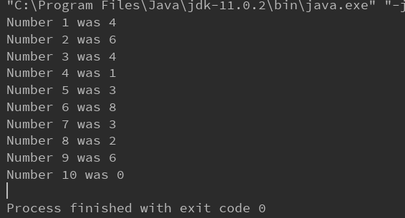

**Pseudocode(Tute4_1b)**

START

1. SET count=1
2. GET random numbers
3. Declaration number
4. DO
5. PRINT number
6. count++
7. IF (number==7)
8. PRINT Lucky7
9. END IF
10. WHILE (number!=0)
11. END DO WHILE

END

**Source code**

import java.util.Random;

public class Tute4_1b {

public static void main(String[] args) {

int count = 1; // initialize count

Random rand = new Random();

int number;

do {

number = rand.nextInt(10) + 0; //10 is the maximum random number and 0 is minimum

System.out.println("Number " + count + " was " + number);

count++; // increment count

if(number == 7){

System.out.println("Lucky 7!");

}

}

while (number != 0);

}

}

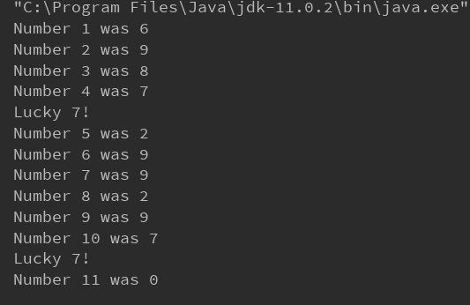

**Task 2 – Number Guessing Game**

**Psudeocode(Tute4_2a)**

START

1. GET random number between 1 to 100
2. Declaration guessNumber
3. SET guessCounter = 0
4. DO
5. PROMPT user enter guess number
6. GET guess number
7. guessCounter++
8. IF(guessNumber > hiddenNumber)
9. PRINT too high
10. END IF
11. ELSE IF (guessNumber < hiddenNumber)
12. PRINT too low
13. END ELSE LF
14. WHILE(guessNumber != hiddenNumber)
15. END DO WHILE
16. PRINT hidden number
17. PRINT guessCounter

END

**Source code**

import java.util.Random;

import java.util.Scanner;

public class Tute4_2a {

public static void main(String[] args) {

Random rand = new Random();

int guessNumber; //declaration guessNumber

int hiddenNumber = rand.nextInt(100) + 1; //100 is the maximum random number and 1 is minimum

int guessCounter = 0; //initialize guessCounter

do {

Scanner scan = new Scanner(System.in);

System.out.print("Guess the number between 1 to 100 : ");

guessNumber = scan.nextInt();

guessCounter++;

if (guessNumber > hiddenNumber) {

System.out.println("Too high !");

}

else if (guessNumber < hiddenNumber) {

System.out.println("Too low !");

}

}while(guessNumber != hiddenNumber);

System.out.println(hiddenNumber + " is correct, you win!");

System.out.println("You got in " +guessCounter+ " guesses");

}

}

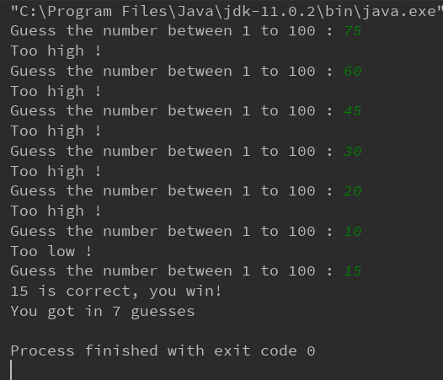

**Psudeocode(Tute4_2b)**

START

1. GET random number between 1 to 100
2. Declaration guessNumber
3. SET guessCounter = 0
4. WHILE(true)
5. PROMPT user enter guess number
6. GET guess number
7. guessCounter++
8. IF(guessNumber > hiddenNumber)
9. PRINT too high
10. END IF
11. ELSE IF (guessNumber < hiddenNumber)
12. PRINT too low
13. END ELSE LF
14. ELSE
15. PRINT hidden number
16. PRINT guessCounter
17. END ELSE
18. Break
19. END WHILE

END

**Source code**

import java.util.Random;

import java.util.Scanner;

public class Tute4_2b {

public static void main(String[] args) {

Random rand = new Random();

int guessNumber; //declaration guessNumber

int hiddenNumber = rand.nextInt(100) + 1; //100 is the maximum random number and 1 is minimum

int guessCounter = 0; //initialize guessCounter

while(true){

Scanner scan = new Scanner(System.in);

System.out.print("Guess the number between 1 to 100 : ");

guessNumber = scan.nextInt();

guessCounter++;

if (guessNumber > hiddenNumber) {

System.out.println("Too high !");

}

else if (guessNumber < hiddenNumber) {

System.out.println("Too low !");

}

else {

System.out.println(hiddenNumber + " is correct, you win!");

System.out.println("You got in " +guessCounter+ " guesses");

break;

}

}

}

}

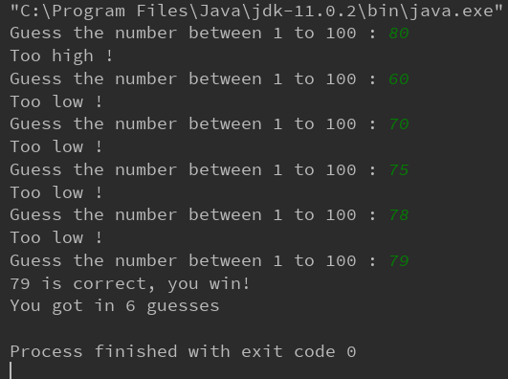

**Task 4 – Lap Time Recorder**

**Source Code**

import java.util.Scanner;

public class Tute4_4a {

public static void main(String[] args) {

double total = 0;

double fastest = 9999;

double slowest = 0;

Scanner scan = new Scanner(System.in);

System.out.print("How many laps: "); // prompt user enter number of laps

int numberOfLaps = scan.nextInt();

for(int i=1; i<=numberOfLaps; i++ ){

System.out.print("Enter lap time "+ i +" lap : "); //prompt user enter lap time

double lapTime = scan.nextDouble();

if(lapTime<fastest){ //set fastest lap

fastest = lapTime;

}

if(lapTime>slowest){ // set slowest lap

slowest =lapTime;

}

total =total+lapTime; // calculate total

}

System.out.println("fastest = "+fastest);

System.out.println("slowest = " + slowest);

double average = Math.round(total/numberOfLaps); // calculate average

System.out.println("average = "+ average);

}

}

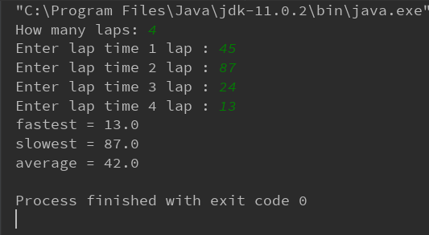

**Source Code**

import java.util.ArrayList;

import java.util.List;

import java.util.Scanner;

import java.util.Collections;

public class Tute4_4b {

public static void main(String[] args) {

double fastest = 9999;

double slowest = 0;

double total =0;

Scanner scan = new Scanner(System.in);

System.out.print("How many laps: "); // prompt user enter number of laps

int numberOfLaps = scan.nextInt();

List<Double> lapTimeList = new ArrayList<>(); // creating arraylist

for(int i=1; i<=numberOfLaps; i++ ) {

System.out.print("Enter lap time " + i + " lap : "); //prompt user enter lap time

double lapTime = scan.nextDouble();

lapTimeList.add(lapTime); // add lapTime to lapTimeList

}

for (int j = 0; j < lapTimeList.size(); j++) {

total = total+ lapTimeList.get(j); //calculate total

}

fastest = Collections.min(lapTimeList); // finding fastest lap

slowest = Collections.max(lapTimeList); // finding slowest lap

System.out.println("fastest = "+fastest);

System.out.println("slowest = " + slowest);

double average = Math.round(total/lapTimeList.size()); // calculate average

System.out.println("average = "+ average);

}

}

